**Electronic Invoicing for the supply Chain Management**

**An Engineering Project in Community Service**

**Phase – I Report**

***Submitted by***

1. 18BCE10047-AnupriyaShroti
2. 18BCE10052-Anushka Shukla
3. 18BCE10234-Sameer Bhadoriya
4. 18BCG10080-Saksham Goyal
5. 18BCG10085-Shivam Shakya
6. 18BCY10002-Aakash Vats
7. 18BCY10007-Adil Mustafa Khokhawala
8. 18BCY10019-Ashutosh Bisawa
9. 18BCY10031-Devyani Senwar
10. 18BCY10107- Tanmay DevangbhaiShelat

***in partial fulfillment of the requirements for the degree of***

***Bachlore of Engineering and Technology***



**VIT Bhopal University**

**Bhopal**

**Madhya pradesh**

**<<May, 2021>>**



**Bonafide Certificate**

Certified that this project report titled **“Electronic Invoicing for the Supply Chain Management”** is the bonafide work of, 18BCE10047-Anupriya Shroti, 18BCE10052-Anushka Shukla, 18BCE10234-Sameer Bhadoriya, 18BCG10080-Saksham Goyal, 18BCG10085-Shivam Shakya, 18BCY10002-Aakash Vats, 18BCY10007-Adil Mustafa Khokhawala, 18BCY10019-Ashutosh Bisawa, 18BCY10031-Devyani Senwar, 18BCY10107-Tanmay D. Shelat who carried out the project work under my supervision.

This project report (Phase I) is submitted for the Project Viva-Voce examination held on …………..

**Supervisor**

# Introduction

## 1.1 Motivation

We are motivated to make this community project in order to help the individuals of the income tax departments, suppliers to generate E bills as they struggle with the traditional methods and often get fooled by the trickery of Legal Consultants etc.

Notably, we are in the intention of helping these people to make the world a tech driven place where people don’t get bullied by 3rd party sources and generate bills, form in a systematic way. Also it reduces the manpower that consumed a lot of time.

## Objective

Digital Invoicing systems have been all over the market for the past few years and many companies have incorporated this strategy in their invoicing procedure to reduce the cost and time associated with it.

Hence we plan on taking it a step further with the use of OCR to work on automating several legal filing systems (Income Tax Returns & GST Returns to start with),

So that the middle class wouldn’t have to be bullied by the “Charges” of Legal Consultants & Chartered Accountants.

# Existing Work / Literature Review

* This project mainly targets the local vendors which are present in the community.​
* The former projects provide all the facilities of OCR and storing the data on a server. ​
* The successor project  will provide the OCR functionalities and storing that in a standardised CSV file, which then can be used to file taxes and GST upon their selection.​
* As well as they will have a track on their sales records, which can be found in our database.​
* This will help optimize the service time.
* **LEXMARK AND NOTFOX**

Lexmark is a company specializing in high-end ITsolutions for established companies, the oracle invoice processing solution offers automatic scanning, data extraction, filing and payment of invoices. One major drawback with Lexmark’s solution is that it does require integration with the end-user business suite.

Fortnox provides a service named ‘Fakturatolkning’ which translates roughly to ‘invoice interpretation’, Fortnox applies its software on the invoices sent by the endusers to them to extract the vital information from it. The extracted information is validated by an employee at Fortnox after which it is inserted into the bookkeeping service offered. The major drawback of Fortnox is that there is human intervention which leaves slack for both, security breaches & humane errors.

# Topic of the work

1. System Design / Architecture

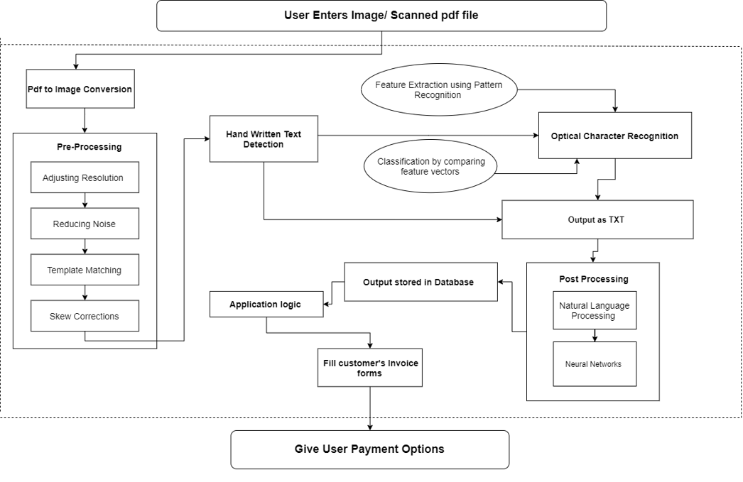

1. Working Principle

Our project works on the OCR, i.e. Optical Character Recognition which basically is the electronic or mechanical conversion of images of typed, handwritten or printed text into machine-encoded text, whether from a scanned document, a photo of a document, a scene-photo or fromsubtitle text superimposed on an image.

It is a business solution for automating data extraction from printed or written text from a scanned document or image file and then converting the text into a machine-readable form to be **used for** data processing like editing or searching.

We implement the OCR system in order to automate several legal filing systems (Income Tax Returns & GST Returns to start with), so that the middle class wouldn’t have to be bullied by the “Charges” of Legal Consultants & Chartered Accountants.

1. Expected Results:

* Ideation of the community project
* Successful completion of Sytem architecture.
* Identification of project modules.
* Working prototype of proof of concept.
  + Input (JPEG,PNG,PDF,JPG)
  + Pre processing of input file.
    - Gray scaling of image
    - Noise removal
    - Thresholding
    - Dialation
    - Canny edge Detection
    - Template matching
  + OCR (Optical Character recognition)
* Front end prototype.

# Conclusion

We conclude that for the phase 1 report, we have a complete plan laid out for the development of the project. This includes all the research, with an architecture diagram which gives the flow and relationship between the project modules which will work at the back-end and working OCR for all the input files. Along with this we also have a front-end prototype ready which gives a glimpse of how the project would look like after its development.

# References

1. https://ieeexplore.ieee.org/document/8576202​
2. https://ieeexplore.ieee.org/document/9151144​
3. <https://link.springer.com/chapter/10.1007/978-3-642-23777-5_22>​
4. Automatic reading and interpretation of paper invoices (UPPSALA UNIVERSITY)​

​